Natural Number Subtraction with Base 10 Blocks

Materials: Base 10 Blocks, writing medium
Video Support: https://www.youtube.com/watch?v=vQKQ-UvvpAg
Goal: to see a visual representation or “Regrouping” or “Borrowing” in subtraction in order to make the symbolic part (crossing off, writing new-found ones) becomes intuitive.

- Represent the minuend. (Subtrahend optional.) | 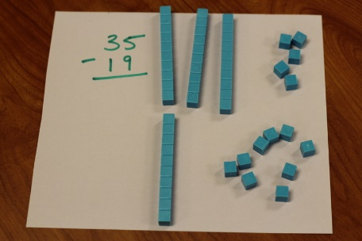
- Prompt that there are too few units in the minuend. Trade one “10” rod in the minuend for ten units. | 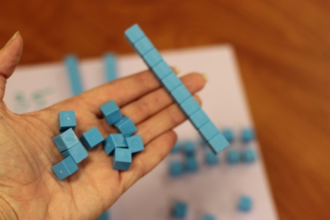
- Represent symbolically. | 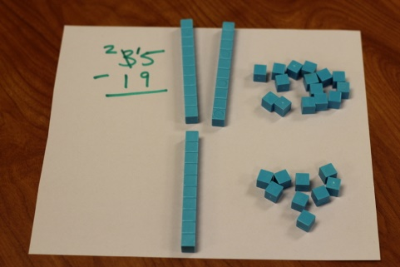
- Subtract. | 